**SPRINT 2**

|  |  |
| --- | --- |
| Date | 18 October 2022 |
| Team ID | PNT2022TMID15063 |
| Project Name | Gas Leakage Monitoring And Alerting system for industries |

**SENDING DATA TO IBM WATSON PLATFORM:**

**The IBM cloud details included in code**

**PUBLISHING SENSOR DATA & RECEIVING IN IBM CLOUD**

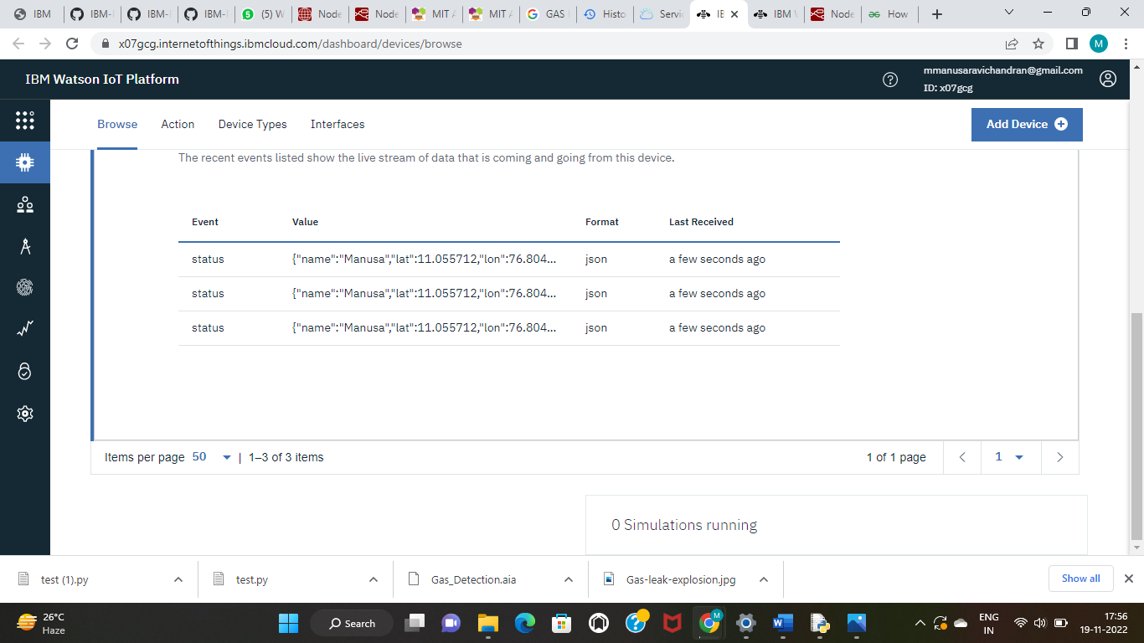

**Sensor Data Received in IBM CloudCloud**